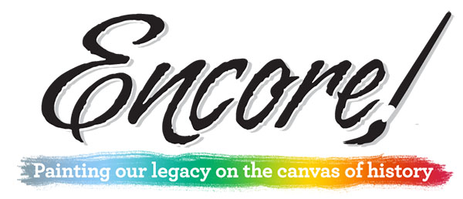

Encore! Mt. Morris

Encore! Mt. Morris Art Show
August 6-29, 2021

Old Sandstone Gallery
Historic Mt. Morris Campus
122 S Wesley Ave.
Mt. Morris IL

Call for Entries

Encore! Mt. Morris
105 W Lincoln St.
Mt. Morris, IL 61054
Email: info@encoremtmorris.com
Information & application, visit: EncoreMtMorris.com Click on Art Show Registration
Facebook: encoremtmorris

Title of the Show: Radical Botanicals
Host: Encore! Mt. Morris, a cultural initiative of the Mt. Morris Economic Development Corp, with the goal of developing Mt. Morris into a unique, thriving, rural and cultural arts destination in northwest Illinois. Show will be held on the Mt. Morris Campus in the Old Sandstone Gallery, 122 S Wesley Ave, Mt. Morris, IL
Call for entries: Encore’s third gallery show of the 2021 season, original art work in any medium, reflecting a “radical botanical” theme. Artists may submit up to 3 images of their original works for consideration. Accepted art works must be the same item(s) that are displayed in the show (no substitutions). Artists must be 18 years old or older. Only those images received by the deadline (July 10) will be considered.

Specifications for gallery art pieces: 2D format: Maximum size: 48” x 48”; minimum framed size: 8 x 10”; weight: <40 pounds; frames: wired for hanging; no warped, dirty or damaged frames please. 3D format: Contact us with your questions about very large works.
Publicity: Encore! Mt. Morris reserves the right to photograph all exhibited work for publicity purposes.
Sales: Art works may be available for sale during the exhibition. Please note that Encore! Mt. Morris retains a 30% commission on all art sales to cover Gallery expenses. Prices may not be changed after submission. Payment for sold art work will be issued within 30 days after the close of the exhibition.
How to enter: Submit an application and images of your art pieces either online or in print.
Online application:
- Complete the Artist Application at EncoreMtMorris.com; click on Art Show Registration button.
- Email JPEG-only images of up to 3 pieces you wish to have considered for the show to entry@EncoreMtMorris.com Each file name should be: last name__first name__your image title.jpeg Images should be <2 MB each, no smaller than 1024 pixels on the longest side, 72 ppi/dpi (standard web resolution), and show no frame or mat.
- Pay the entry fee of $20 for 1-3 images (or free if you provide an art item for the Encore Art Auction fundraiser scheduled for February 2022). Fees can be charged through PayPal including credit cards. Fees must be paid at the time of the application.
- If you prefer not paying the fee online, you may send a check to the Village Hall, 105 W. Lincoln St, Mt. Morris IL 61054. Make the check out to Encore! Mt. Morris and put “August Art Show” on the memo line

Print application:
- Complete the Artist Application included in the last page of this document.
- Include a 4x6 photo of each gallery art piece you want us to consider for the shows. Write your name and title of the piece on the back of the photo. These photos will not be returned.
- Pay the entry fee. Fee must be paid at the time of the application. Make a check out to Encore! Mt. Morris and put “August Art Show” on the memo line.
- Mail the packet to Encore!, c/o Radical Botanicals Art Show, 105 W Lincoln St., Mt Morris, IL 61054.

Insurance and Liability: Every care will be taken to safeguard all work shown under Encore! Mt. Morris’s sponsorship, including a gallery host on the premesis whenever the gallery is open. However, all persons submitting artwork for the exhibition are encouraged to maintain their own insurance on their works. Encore! Mt. Morris maintains general liability only, which covers the art in case of major incidents such as fire, theft or sprinkling system failure. We also have a lockable display case for valuable, smaller items.
Calendar
July 10: Deadline for receipt of entries (postmarks or dated online submission)
July 11-15: Jury selection of art works and artists notified via email.
July 26: Deadline for receipt of all artist agreements and requested materials (artist bio, artist statement or description of the artistic process used to create the work, artist photo)
August 3 & 4: Art work installed in Gallery (Aug 4 soft opening)
August 6 - 29: Exhibition dates
August 6th: Opening reception (artists invited), 6-9:00pm
August 30-31st: Pickup of unsold work. Any work not picked up within 10 days after will become the property of Encore! Mt. Morris.

Contact us with your questions.
mollyb@encoremtmorris.com
309-255-1096
________________________________________________________________________________________________

Artist Application
(Online applications preferred; This form only needed for mail-in applications.)

Artist name: __________________________________________________________
Address: ______________________________________________________________
City/State/Zip: _______________________________________________________
Email: __________________________________________
Phone: __________________________________

Gallery piece: 1st Entry Title: _________________________________________________________
Medium: _________________ Size: ______ x ________ x _________

Gallery piece: 2nd Entry Title: _________________________________________________________
Medium: ___________________ Size: ______ x ________ x _________

Gallery piece: 3rd Entry Title: _________________________________________________________
Medium: _________________ Size: ______ x ________ x _________

Contact us with your questions.
mollyb@encoremtmorris.com
309-255-1096

